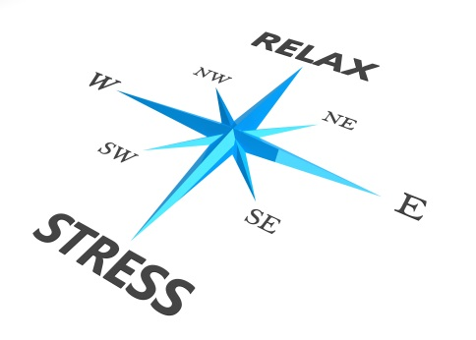

**Assess Your Stress and Time Management Skills**

**Directions:** Score each item using the following scale:

1 = Always 2 = Almost Always 3 = Sometimes 4 = Almost Never 5 = Never

1. I eat at least one hot, balanced meal a day. ____
2. I get seven to eight hours of sleep at least 4 nights a week. ____
3. I exercise at least 3 times a week for 30 minutes at a time. ____
4. I do not smoke. ____
5. I take fewer than five alcoholic drinks a week. ____
6. I have the appropriate weight for my height. ____
7. I study at least three hours per day for each hour spent in class. ____
8. I regularly attend club or social activities. ____
9. I am in good health. ____
10. There are enough hours in the day. ____
11. I do something for fun every week. ____
12. I never cram the night before a test. ____
13. I maintain a study schedule. ____
14. I am able to organize my time effectively. ____
15. I take quiet time for myself during the day. ____
16. I find time to get the important things done. ____
17. I drink less than 3 caffeinated beverages a day. ____
18. I feel that my life is going at a comfortable pace. ____
19. I am able to realize when I’m taking on too many responsibilities. ____
20. I practice stress management techniques. ____



**Scoring:** Add up the figures and subtract 20.

0 - 29 Excellent stress and time management skills

30 - 49 Fair stress and time management skills

50 - 75 Poor stress and time management skills

Over 75 Terrible stress and time management skills

Managing your time and stress can help you to succeed!